Software Requirements Specification
for
Telecom Customers Churn Prediction System
Prepared by
 | Names | Registration Number | Signature
1 | KYANZI HASSAN MUSISI | 17/U/19979/EVE
2 | WAMALA EDGAR WATSON | 17/U/20633/EVE
3 | KASOZI JAFFAR | 17/U/4741/EVE
4 | BWAYO JOEL | 17/U/3777/EVE

Makerere University
July 2019

Table of Contents
1. Introduction 1
1.1 Purpose 1
1.2 Telecom Customer churn:A brief explanation 1
1.3 Reducing Churn Rates Through Predictive Analytics Pipeline 1
2. Data Pipeline:From raw data to predictive model 1
2.1 Loading the data 1
2.2 Data wrangling 1
2.3 Data visualization 2
2.4 Application of Logistic Regression 2
2.4.1 Model building in Scikit-learn 2
2.4.2 2.4.2 Model Development and Prediction 2
2.5 Logistic Model Evaluation 2
3. Use Class Diagram 3
3.1 Use class Diagram Description 3

Introduction

Purpose
The purpose of this document is to describe the use cases of our data pipeline for our system. This document will give a detailed description of who uses the data pipeline,what they use it for and reasons as to why they use this data pipeline.

Telecom Customer churn:A brief explanation
Customer churn or attrition measures the number of customers who may defect or discontinue using a service or subscribing to it in a given period of time.. Churn rate is an important business function as it helps reflect customer response to company services, pricing and competition with other companies. As such, measuring churn, understanding the underlying reasons and being able to anticipate the propensity to churn and manage risks associated to it are key areas for continuous increase in business value.

Reducing Churn Rates Through Predictive Analytics Pipeline
The predictive churn model will achieve three goals which are;
- To understand they key factors of customer churn
- To identify the clients who are most likely to churn
- To provide targeted insights on which customer churn measures or retention action should be implemented.

Data Pipeline:From raw data to predictive model

Loading the data
Our first task is loading the comma separated values(csv) Telco customer churn file into the Anaconda Jupyter Notebook.

Data wrangling
This involves looking for outliers, missing values , taking care of noise like in some of our feature that have “No service” instead of “No”.
It also involves encoding basically label and one hot encoding to change non numerical and categorical values to numerical.
It also involves normalizing of our data or feature scaling it .

Data visualization
This involves representing the data in a visual context. It also helps to show how skewed the data is especially with the histogram.

Application of Logistic Regression
We are using logistic regression as our classifier. Our problem needs binary logistic regression since it has an output of either “Churn” or “No churn”.

Model building in Scikit-learn
When building the telecom customer churn prediction model we use the logistic regression classifier. You start by selecting features which involves dividing all features to dependent and independent variables. Which is followed by splitting the data, to understand the model we need to divide the dataset into train and test sets.

2.4.2 Model Development and Prediction
We start by importing the Logistic Regression module and create a Logistic Regression classifier object using LogisticRegression() function.
We then fit our model on the train set using fit() and perform prediction on the test set using predict().

Logistic Model Evaluation
Here we evaluate the logistic model using model evaluation functions such as accuracy, precision, and recall.

Use Class Diagram
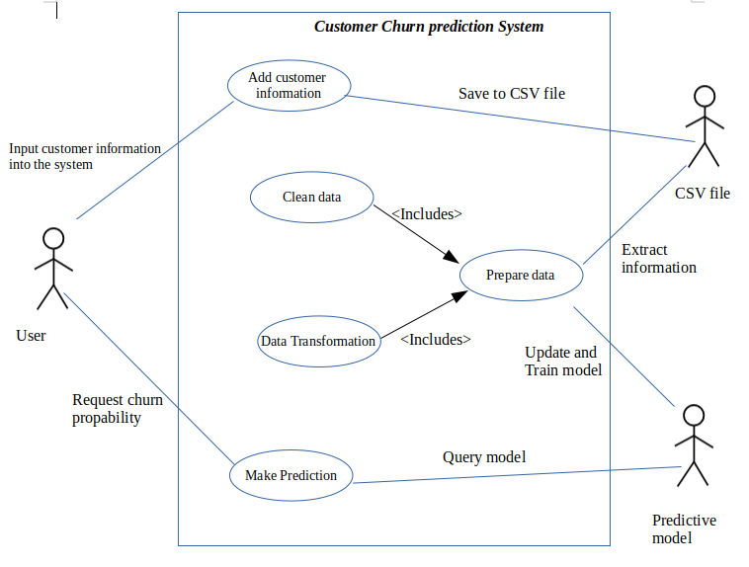

Use class Diagram Description
This system has majorly three actors that’s the user as the primary actor , the CSV and predictive model as secondary actors.
The user can load or add more customer features and store them into the CSV file for manipulation through the Add customer information use case.
Information is extracted from the CSV file to be Cleaned and Transformed. Every time data is cleaned and transformed that means its being prepared to be split into train and test for the predictive model to perform predictions on it. And this is done by Clean data use case ,Data Transformation use case and Prepare Data use case
The user actor can request for churn probability through Make Prediction use case that is being calculated by the predictive model hence logistic regression.

